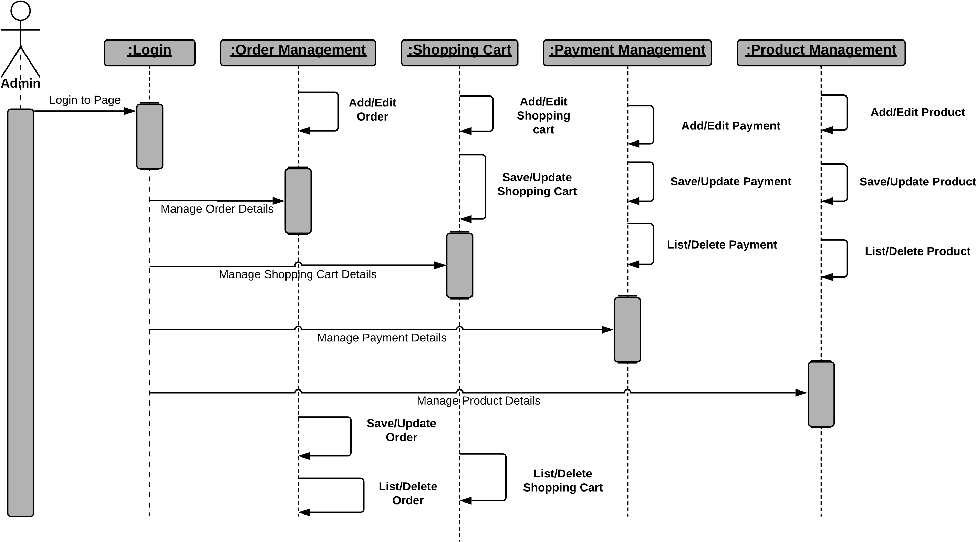 *Sequence Diagram Online Cloth Mart*